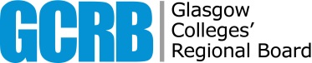

Nominations & Remuneration Committee
Date of Meeting | 12 December 2019
Paper Title | Review of Disclosable Status
Agenda Item | 13
Paper Number | NRC2-G
Responsible Officer | Penny Davis, Board Secretary
Status | Disclosable
Action | For Noting

Please be reminded that the following papers are currently non-disclosable:

NRC2-A Draft Minutes of N&R Committee held 10 October 2019
NRC2-D N&R Committee Annual Report

